S.N. | Regulation No. | Tariff Regulations 2019 | Draft Tariff Regulations 2024 | JITPL Comments/Suggestions on the Draft Regulations 2024
1 | Regulation 64 | The income from  other business of transmission licensee shall be shared with the long term customer in  the manner as specified in the Central Electricity Regulatory Commission (Sharing of  revenue derived from utilization of transmission assets for other business) Regulations,  2007. | In case of part or full use of an alternative source of fuel supply by coal based thermal generating stations other than as agreed by the generating company and beneficiaries in their power purchase agreement for the supply of contracted power on account of a shortage of fuel or optimization of economical operation through blending, the use of an alternative source of fuel supply shall be permitted to generating station up to a maximum of 6% blending by weight | Hon'ble commission may kindly consider not to restrict at 6% and should be allowed at actual based on direction issued by ministry on time to time basis.
2 | Regulation 70 | For Coal-based and lignite-fired Thermal Generating Stations:  1.05 X Design Heat Rate (kCal/kWh) | (i) For Coal-based and lignite-fired Thermal Generating Stations:  For 200/210/250 MW Sets. : 1.05 X Design Heat Rate (kCal/kWh)  For 500 MW Sets and above: 1.04 X Design Heat Rate (kCal/kWh) | In the previous regulations the Station Heat Rate was taken at 1.05 X Designed Heat Rate irrespective od Unit Size.  The same may be retained as per the previous regulation at 1.05 irrespective of Unit Size as Higher Capacity Units running at Part Load or Under Flexible Operation have higher Heat Rate deterioration compared to smaller Unit Size
3 | Regulation 70 | 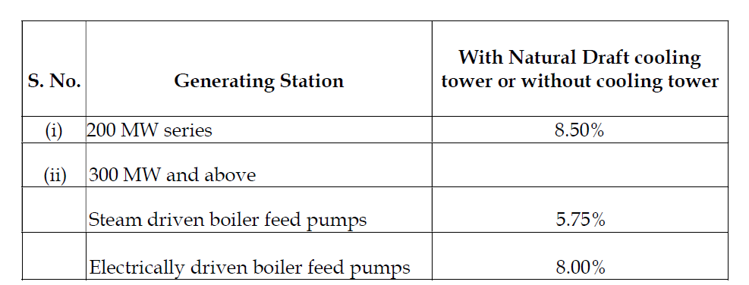 | 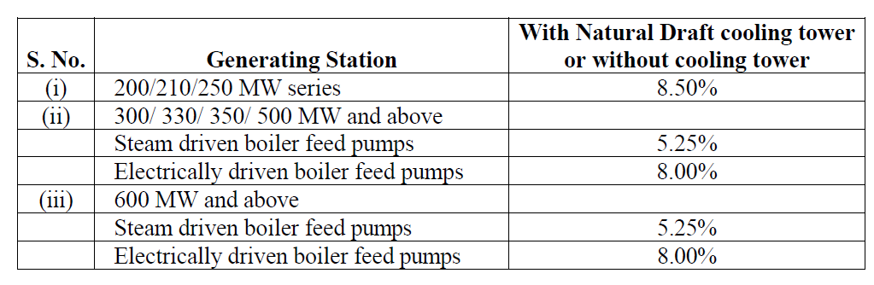 | In the previous regulations, the Auxiliary Energy Consumption was taken at 5.75%.  There has been not much technological upgradation in the Plant who have CODs post 01.04.2009.  Thus there prima facie seems no reason to reduce the APC from 5.75% to 5.25%.  Request to retain the APC parameter as per previous regulation.

